Sommaire
Advanced SQL 3
1. JOINs AND UNIONs 3
1.1 COURS 3
Introduction 3
JOINs 3
UNIONs 4
Example 6
1.2 EXERCICES 10
Introduction 10
Exercises 10
1) How long does it take for questions to receive answers? 10
2) Initial questions and answers, Part 1 12
3) Initial questions and answers, Part 2 14
4) How many distinct users posted on January 1, 2019? 16
2. Analytic Functions 18
2.1 COURS 18
Introduction 18
Syntax 18
Three types of analytic functions 19
1) Analytic aggregate functions 19
2) Analytic navigation functions 19
3) Analytic numbering functions 20
Example 20
2.2 EXERCICES 23
Introduction 23
Exercises 23
1) How can you predict the demand for taxis? 23
2) Can you separate and order trips by community area? 25
3) How much time elapses between trips? 27
3. Nested and Repeated Data 29
3.1 COURS 29
Introduction 29
Nested data 29
Repeated data 32
Nested and repeated data 33
Example 34
3.2 EXERCICES 38
Introduction 38
Exercises 38
1) Who had the most commits in 2016? 38
2) Look at languages! 42
3) What's the most popular programming language? 44
4) Which languages are used in the repository with the most languages? 44
4. Writing Efficient Queries 46
4.1 COURS 46
Introduction 46
Some useful functions 46
Strategies 46
1) Only select the columns you want. 46
2) Read less data. 47
3) Avoid N:N JOINs. 47
Learn more 50
4.2 EXERCICES 51
Introduction 51
Exercises 51
1) You work for Pet Costumes International. 51
2) Make it easier to find Mitzie! 52

Advanced SQL
Take your SQL skills to the next level.

1. JOINs AND UNIONs

1.1 COURS

Introduction
In the Intro to SQL micro-course, you learned how to use INNER JOIN to consolidate information from two different tables. Now you'll learn about a few more types of JOIN, along with how to use UNIONs to pull information from multiple tables.
Along the way, we'll work with two imaginary tables, called owners and pets.
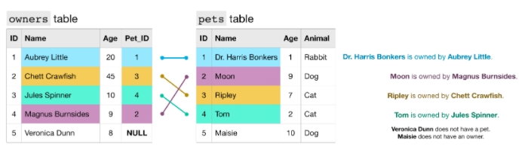
Each row of the owners table identifies a different pet owner, where the ID column is a unique identifier. The Pet_ID column (in the owners table) contains the ID for the pet that belongs to the owner (this number matches the ID for the pet from the pets table).
For example,
- the pets table shows that Dr. Harris Bonkers is the pet with ID 1.
- The owners table shows that Aubrey Little is the owner of the pet with ID 1.
Putting these two facts together, Dr. Harris Bonkers is owned by Aubrey Little. Likewise, since Veronica Dunn does not have a corresponding Pet_ID, she does not have a pet. And, since 5 does not appear in the Pet_ID column, Maisie does not have an owner.

JOINs
Recall that we can use an INNER JOIN to pull rows from both tables where the value in the Pet_ID column in the owners table has a match in the ID column of the pets table.
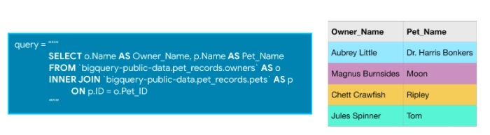
In this case, Veronica Dunn and Maisie are not included in the results. But what if we instead want to create a table containing all pets, regardless of whether they have owners? Or, what if we want to combine all of the rows in both tables? In these cases, we need only use a different type of JOIN.
For instance, to create a table containing all rows from the owners table, we use a LEFT JOIN. In this case, "left" refers to the table that appears before the JOIN in the query. ("Right" refers to the table that is after the JOIN.)
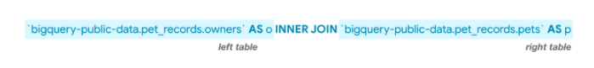
Replacing INNER JOIN in the query above with LEFT JOIN returns all rows where the two tables have matching entries, along with all of the rows in the left table (whether there is a match or not).
If we instead use a RIGHT JOIN, we get the matching rows, along with all rows in the right table (whether there is a match or not).
Finally, a FULL JOIN returns all rows from both tables. Note that in general, any row that does not have a match in both tables will have NULL entries for the missing values. You can see this in the image below.

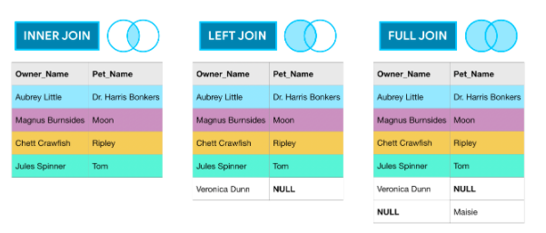
UNIONs
As you've seen, JOINs horizontally combine results from different tables. If you instead would like to vertically concatenate columns, you can do so with a UNION. The example query below combines the Age columns from both tables.
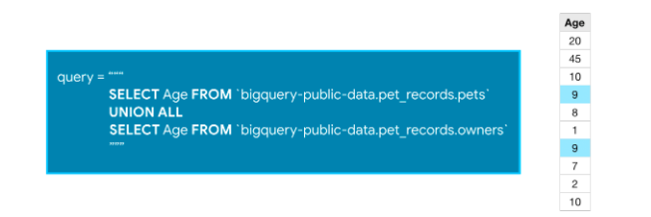
Note that with a UNION, the data types of both columns must be the same, but the column names can be different. (So, for instance, we cannot take the UNION of the Age column from the owners table and the Pet_Name column from the pets table.)
We use UNION ALL to include duplicate values - you'll notice that 9 appears in both the owners table and the pets table, and shows up twice in the concatenated results. If you'd like to drop duplicate values, you need only change UNION ALL in the query to UNION DISTINCT.

Example
We'll work with the Hacker News dataset. We begin by reviewing the first several rows of the comments table. (The corresponding code is hidden, but you can un-hide it by clicking on the "Code" button below.)
Using Kaggle's public dataset BigQuery integration.

id | by | author | time | time_ts | text | parent | deleted | dead | ranking
0 | 2701393 | 5l | 5l | 1309184881 | 2011-06-27 14:28:01+00:00 | And the glazier who fixed all the broken windo... | 2701243 | None | None | 0
1 | 5811403 | 99 | 99 | 1370234048 | 2013-06-03 04:34:08+00:00 | Does canada have the equivalent of H1B/Green c... | 5804452 | None | None | 0
2 | 21623 | AF | AF | 1178992400 | 2007-05-12 17:53:20+00:00 | Speaking of Rails, there are other options in ... | 21611 | None | None | 0
3 | 10159727 | EA | EA | 1441206574 | 2015-09-02 15:09:34+00:00 | Humans and large livestock (and maybe even pet... | 10159396 | None | None | 0
4 | 2988424 | Iv | Iv | 1315853580 | 2011-09-12 18:53:00+00:00 | I must say I reacted in the same way when I re... | 2988179 | None | None | 0
You'll also work with the stories table.
Code
Out[2]:
 | id | by | score | time | time_ts | title | url | text | deleted | dead | descendants | author
0 | 6940813 | sarath237 | 0 | 1387536270 | 2013-12-20 10:44:30+00:00 | Sheryl Brindo Hot Pics | http://www.youtube.com/watch?v=ym1cyxneB0Y | Sheryl Brindo Hot Pics | None | True | NaN | sarath237
1 | 6991401 | 123123321321 | 0 | 1388508751 | 2013-12-31 16:52:31+00:00 | Are you people also put off by the culture of ... |  | They&#x27;re pretty explicitly &#x27;startup f... | None | True | NaN | 123123321321
2 | 1531556 | ssn | 0 | 1279617234 | 2010-07-20 09:13:54+00:00 | New UI for Google Image Search | http://googlesystem.blogspot.com/2010/07/googl... | Again following on Bing's lead. | None | None | 0.0 | ssn
3 | 5012398 | hoju | 0 | 1357387877 | 2013-01-05 12:11:17+00:00 | Historic website screenshots | http://webscraping.com/blog/Generate-website-s... | Python script to generate historic screenshots... | None | None | 0.0 | hoju
4 | 7214182 | kogir | 0 | 1401561740 | 2014-05-31 18:42:20+00:00 | Placeholder |  | Mind the gap. | None | None | 0.0 | kogir
Since you are already familiar with JOINs from the Intro to SQL micro-course, we'll work with a relatively complex example of a JOIN that uses a common table expression (CTE).
The query below pulls information from the stories and comments tables to create a table showing all stories posted on January 1, 2012, along with the corresponding number of comments. We use a LEFT JOIN so that the results include stories that didn't receive any comments.
In [3]:
# Query to select all stories posted on January 1, 2012, with number of comments
join_query = """
WITH c AS
(
SELECT parent, COUNT(*) as num_comments
FROM `bigquery-public-data.hacker_news.comments`
GROUP BY parent
)
SELECT s.id as story_id, s.by, s.title, c.num_comments
FROM `bigquery-public-data.hacker_news.stories` AS s
LEFT JOIN c
ON s.id = c.parent
WHERE EXTRACT(DATE FROM s.time_ts) = '2012-01-01'
ORDER BY c.num_comments DESC
"""

# Run the query, and return a pandas DataFrame
join_result = client.query(join_query).result().to_dataframe()
join_result.head()
Out[3]:
 | story_id | by | title | num_comments
0 | 3412900 | whoishiring | Ask HN: Who is Hiring? (January 2012) | 154.0
1 | 3412901 | whoishiring | Ask HN: Freelancer? Seeking freelancer? (Janua... | 97.0
2 | 3412643 | jemeshsu | Avoid Apress | 30.0
3 | 3412891 | Brajeshwar | There's no shame in code that is simply "good ... | 27.0
4 | 3414012 | ramanujam | Impress.js - a Prezi like implementation using... | 27.0
Since the results are ordered by the num_comments column, stories without comments appear at the end of the DataFrame. (Remember that NaN stands for "not a number".)
In [4]:
# None of these stories received any comments
join_result.tail()
Out[4]:
 | story_id | by | title | num_comments
439 | 3413269 | wireheadlance | On 2011: The Year of System Failure | NaN
440 | 3412995 | benjlang | Android app search engine | NaN
441 | 3413806 | jensnockert | Nyan Cat progress indicators for your Mac | NaN
442 | 3412769 | syedmuddassar | Ballroom Dance Shoes | NaN
443 | 3413361 | learnphp123 | Easy AJAX Pagination Using JQuery CakePHP | NaN
Next, we write a query to select all usernames corresponding to users who wrote stories or comments on January 1, 2014. We use UNION DISTINCT (instead of UNION ALL) to ensure that each user appears in the table at most once.
In [5]:
# Query to select all users who posted stories or comments on January 1, 2014
union_query = """
SELECT c.by
FROM `bigquery-public-data.hacker_news.comments` AS c
WHERE EXTRACT(DATE FROM c.time_ts) = '2014-01-01'
UNION DISTINCT
SELECT s.by
FROM `bigquery-public-data.hacker_news.stories` AS s
WHERE EXTRACT(DATE FROM s.time_ts) = '2014-01-01'
"""

# Run the query, and return a pandas DataFrame
union_result = client.query(union_query).result().to_dataframe()
union_result.head()
Out[5]:
 | by
0 | vitd
1 | gpvos
2 | mbell
3 | znowi
4 | GSimon
To get the number of users who posted on January 1, 2014, we need only take the length of the DataFrame.
In [6]:
# Number of users who posted stories or comments on January 1, 2014
len(union_result)
Out[6]:
2282

1.2 EXERCICES

Introduction
Here, you'll use different types of SQL JOINs to answer questions about the Stack Overflow dataset.
Before you get started, run the following cell to set everything up.

The code cell below fetches the posts_questions table from the stackoverflow dataset. We also preview the first five rows of the table.

from google.cloud import bigquery

# Create a "Client" object
client = bigquery.Client()

# Construct a reference to the "stackoverflow" dataset
dataset_ref = client.dataset("stackoverflow", project="bigquery-public-data")

# API request - fetch the dataset
dataset = client.get_dataset(dataset_ref)

# Construct a reference to the "posts_questions" table
table_ref = dataset_ref.table("posts_questions")

# API request - fetch the table
table = client.get_table(table_ref)

# Preview the first five lines of the table
client.list_rows(table, max_results=5).to_dataframe()

We also take a look at the posts_answers table.

# Construct a reference to the "posts_answers" table
table_ref = dataset_ref.table("posts_answers")

# API request - fetch the table
table = client.get_table(table_ref)

# Preview the first five lines of the table
client.list_rows(table, max_results=5).to_dataframe()

You will work with both of these tables to answer the questions below.

Exercises

1) How long does it take for questions to receive answers?
You're interested in exploring the data to have a better understanding of how long it generally takes for questions to receive answers. Armed with this knowledge, you plan to use this information to better design the order in which questions are presented to Stack Overflow users.
With this goal in mind, you write the query below, which focuses on questions asked in January 2018. It returns a table with two columns:
- q_id - the ID of the question
- time_to_answer - how long it took (in seconds) for the question to receive an answer
Run the query below (without changes), and take a look at the output.
first_query = """
SELECT q.id AS q_id,
MIN(TIMESTAMP_DIFF(a.creation_date, q.creation_date, SECOND)) as time_to_answer
FROM `bigquery-public-data.stackoverflow.posts_questions` AS q
INNER JOIN `bigquery-public-data.stackoverflow.posts_answers` AS a
ON q.id = a.parent_id
WHERE q.creation_date >= '2018-01-01' and q.creation_date < '2018-02-01'
GROUP BY q_id
ORDER BY time_to_answer
"""

first_result = client.query(first_query).result().to_dataframe()
print("Percentage of answered questions: %s%%" % \
(sum(first_result["time_to_answer"].notnull()) / len(first_result) * 100))
print("Number of questions:", len(first_result))
first_result.head()

Percentage of answered questions: 100.0%
Number of questions: 134526

 | q_id | time_to_answer
0 | 48369687 | 0
1 | 48350506 | 0
2 | 48054907 | 0
3 | 48118024 | 0
4 | 48123689 | 0

You're surprised at the results and strongly suspect that something is wrong with your query. In particular,
- According to the query, 100% of the questions from January 2018 received an answer. But, you know that ~80% of the questions on the site usually receive an answer.
- The total number of questions is surprisingly low. You expected to see at least 150,000 questions represented in the table.
Given these observations, you think that the type of JOIN you have chosen has inadvertently excluded unanswered questions. Using the code cell below, can you figure out what type of JOIN to use to fix the problem so that the table includes unanswered questions?
Note: You need only amend the type of JOIN (i.e., INNER, LEFT, RIGHT, or FULL) to answer the question successfully.

# Your code here
correct_query = """
SELECT q.id AS q_id,
MIN(TIMESTAMP_DIFF(a.creation_date, q.creation_date, SECOND)) as time_to_answer
FROM `bigquery-public-data.stackoverflow.posts_questions` AS q
LEFT JOIN `bigquery-public-data.stackoverflow.posts_answers` AS a
ON q.id = a.parent_id
WHERE q.creation_date >= '2018-01-01' and q.creation_date < '2018-02-01'
GROUP BY q_id
ORDER BY time_to_answer
"""

# Check your answer
q_1.check()

# Run the query, and return a pandas DataFrame
correct_result = client.query(correct_query).result().to_dataframe()
print("Percentage of answered questions: %s%%" % \
(sum(correct_result["time_to_answer"].notnull()) / len(correct_result) * 100))
print("Number of questions:", len(correct_result))

Hint: Is the posts_questions table the LEFT or RIGHT table? You want to keep all of the rows from this table, regardless of whether or not there is a match in the posts_answers table.
Solution:

correct_query = """
SELECT q.id AS q_id,
MIN(TIMESTAMP_DIFF(a.creation_date, q.creation_date, SECOND)) as time_to_answer
FROM `bigquery-public-data.stackoverflow.posts_questions` AS q
LEFT JOIN `bigquery-public-data.stackoverflow.posts_answers` AS a
ON q.id = a.parent_id
WHERE q.creation_date >= '2018-01-01' and q.creation_date < '2018-02-01'
GROUP BY q_id
ORDER BY time_to_answer
"""

2) Initial questions and answers, Part 1
You're interested in understanding the initial experiences that users typically have with the Stack Overflow website. Is it more common for users to first ask questions or provide answers? After signing up, how long does it take for users to first interact with the website? To explore this further, you draft the (partial) query in the code cell below.
The query returns a table with three columns:
- owner_user_id - the user ID
- q_creation_date - the first time the user asked a question
- a_creation_date - the first time the user contributed an answer
You want to keep track of users who have asked questions, but have yet to provide answers. And, your table should also include users who have answered questions, but have yet to pose their own questions.
With this in mind, please fill in the appropriate JOIN (i.e., INNER, LEFT, RIGHT, or FULL) to return the correct information.
Note: You need only fill in the appropriate JOIN. All other parts of the query should be left as-is. (You also don't need to write any additional code to run the query, since the cbeck() method will take care of this for you.)
To avoid returning too much data, we'll restrict our attention to questions and answers posed in January 2019. We'll amend the timeframe in Part 2 of this question to be more realistic!

# Your code here
q_and_a_query = """
SELECT q.owner_user_id AS owner_user_id,
MIN(q.creation_date) AS q_creation_date,
MIN(a.creation_date) AS a_creation_date
FROM `bigquery-public-data.stackoverflow.posts_questions` AS q
FULL JOIN `bigquery-public-data.stackoverflow.posts_answers` AS a
ON q.owner_user_id = a.owner_user_id
WHERE q.creation_date >= '2019-01-01' AND q.creation_date < '2019-02-01'
AND a.creation_date >= '2019-01-01' AND a.creation_date < '2019-02-01'
GROUP BY owner_user_id
"""

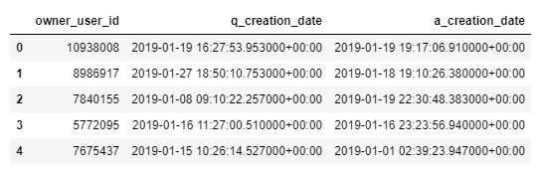

Hint: Which type of JOIN always returns all rows from both tables?
Solution:

q_and_a_query = """
SELECT q.owner_user_id AS owner_user_id,
MIN(q.creation_date) AS q_creation_date,
MIN(a.creation_date) AS a_creation_date
FROM `bigquery-public-data.stackoverflow.posts_questions` AS q
FULL JOIN `bigquery-public-data.stackoverflow.posts_answers` AS a
ON q.owner_user_id = a.owner_user_id
WHERE q.creation_date >= '2019-01-01' AND q.creation_date < '2019-02-01'
AND a.creation_date >= '2019-01-01' AND a.creation_date < '2019-02-01'
GROUP BY owner_user_id

3) Initial questions and answers, Part 2
Now you'll address a more realistic (and complex!) scenario. To answer this question, you'll need to pull information from three different tables! This syntax very similar to the case when we have to join only two tables. For instance, consider the three tables below.
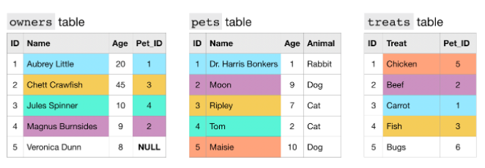
We can use two different JOINs to link together information from all three tables, in a single query.
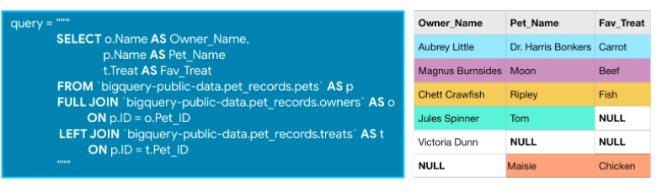
With this in mind, say you're interested in understanding users who joined the site in January 2019. You want to track their activity on the site: when did they post their first questions and answers, if ever?
Write a query that returns the following columns:
- id - the IDs of all users who created Stack Overflow accounts in January 2019 (January 1, 2019, to January 31, 2019, inclusive)
- q_creation_date - the first time the user posted a question on the site; if the user has never posted a question, the value should be null
- a_creation_date - the first time the user posted a question on the site; if the user has never posted a question, the value should be null
Note that questions and answers posted after January 31, 2019, should still be included in the results. And, all users who joined the site in January 2019 should be included (even if they have never posted a question or provided an answer).
The query from the previous question should be a nice starting point to answering this question! You'll need to use the posts_answers and posts_questions tables. You'll also need to use the users table from the Stack Overflow dataset. The relevant columns from the users table are id (the ID of each user) and creation_date (when the user joined the Stack Overflow site, in DATETIME format).
# Your code here
three_tables_query = """
SELECT u.id AS id,
MIN(q.creation_date) AS q_creation_date,
MIN(a.creation_date) AS a_creation_date
FROM `bigquery-public-data.stackoverflow.users` AS u
LEFT JOIN `bigquery-public-data.stackoverflow.posts_answers` AS a
ON u.id = a.owner_user_id
LEFT JOIN `bigquery-public-data.stackoverflow.posts_questions` AS q
ON q.owner_user_id = u.id
WHERE u.creation_date >= '2019-01-01' and u.creation_date < '2019-02-01'
GROUP BY id
"""

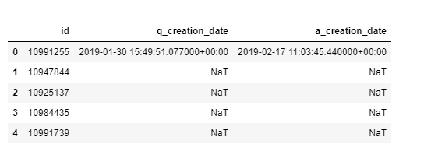
Hint: Here's a partially completed query. You need only fill in the appropriate JOINs!
three_tables_query = """
SELECT u.id AS id,
MIN(q.creation_date) AS q_creation_date,
MIN(a.creation_date) AS a_creation_date
FROM `bigquery-public-data.stackoverflow.users` AS u
____ `bigquery-public-data.stackoverflow.posts_answers` AS a
ON u.id = a.owner_user_id
____ `bigquery-public-data.stackoverflow.posts_questions` AS q
ON q.owner_user_id = u.id
WHERE u.creation_date >= '2019-01-01' and u.creation_date < '2019-02-01'
GROUP BY id
"""
Solution:

three_tables_query = """
SELECT u.id AS id,
MIN(q.creation_date) AS q_creation_date,
MIN(a.creation_date) AS a_creation_date
FROM `bigquery-public-data.stackoverflow.users` AS u
LEFT JOIN `bigquery-public-data.stackoverflow.posts_answers` AS a
ON u.id = a.owner_user_id
LEFT JOIN `bigquery-public-data.stackoverflow.posts_questions` AS q
ON q.owner_user_id = u.id
WHERE u.creation_date >= '2019-01-01' and u.creation_date < '2019-02-01'
GROUP BY id
"""

4) How many distinct users posted on January 1, 2019?
In the code cell below, write a query that returns a table with a single column:
- owner_user_id - the IDs of all users who posted at least one question or answer on January 1, 2019. Each user ID should appear at most once.
In the posts_questions (and posts_answers) tables, you can get the ID of the original poster from the owner_user_id column. Likewise, the date of the original posting can be found in the creation_date column.
In order for your answer to be marked correct, your query must use a UNION.

# Your code here
all_users_query = """
SELECT q.owner_user_id
FROM `bigquery-public-data.stackoverflow.posts_questions` AS q
WHERE EXTRACT(DATE FROM q.creation_date) = '2019-01-01'
UNION DISTINCT
SELECT a.owner_user_id
FROM `bigquery-public-data.stackoverflow.posts_answers` AS a
WHERE EXTRACT(DATE FROM a.creation_date) = '2019-01-01'
"""

Hint: Begin by writing two separate queries: one to get the user IDs corresponding to questions, and another corresponding to answers. Then, take the union of the two columns.
Solution:

all_users_query = """
SELECT q.owner_user_id
FROM `bigquery-public-data.stackoverflow.posts_questions` AS q
WHERE EXTRACT(DATE FROM q.creation_date) = '2019-01-01'
UNION DISTINCT
SELECT a.owner_user_id
FROM `bigquery-public-data.stackoverflow.posts_answers` AS a
WHERE EXTRACT(DATE FROM a.creation_date) = '2019-01-01'
"""

2. Analytic Functions

2.1 COURS

Introduction
In the Intro to SQL micro-course, you learned how to use aggregate functions, which perform calculations based on sets of rows. In this tutorial, you'll learn how to define analytic functions, which also operate on a set of rows. However, unlike aggregate functions, analytic functions return a (potentially different) value for each row in the original table.
Analytic functions allow us to perform complex calculations with relatively straightforward syntax. For instance, we can quickly calculate moving averages and running totals, among other quantities.

Syntax
To understand how to write analytic functions, we'll work with a small table containing data from two different people who are training for a race. The id column identifies each runner, the date column holds the day of the training session, and time shows the time (in minutes) that the runner dedicated to training. Say we'd like to calculate a moving average of the training times for each runner, where we always take the average of the current and previous training sessions. We can do this with the following query:

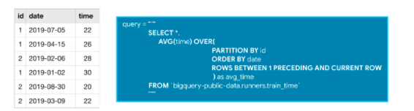
All analytic functions have an OVER clause, which defines the sets of rows used in each calculation. The OVER clause has three (optional) parts:
- The PARTITION BY clause divides the rows of the table into different groups. In the query above, we divide by id so that the calculations are separated by runner.
- The ORDER BY clause defines an ordering within each partition. In the sample query, ordering by the date column ensures that earlier training sessions appear first.
- The final clause (ROWS BETWEEN 1 PRECEDING AND CURRENT ROW) is known as a window frame clause. It identifies the set of rows used in each calculation. We can refer to this group of rows as a window. (Actually, analytic functions are sometimes referred to as analytic window functions or simply window functions!)
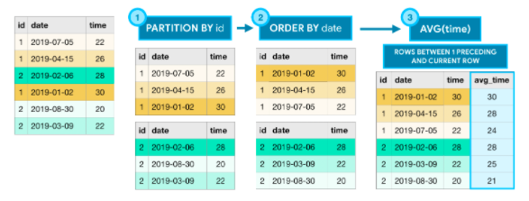
(More on) window frame clauses
There are many ways to write window frame clauses:
- ROWS BETWEEN 1 PRECEDING AND CURRENT ROW - the previous row and the current row.
- ROWS BETWEEN 3 PRECEDING AND 1 FOLLOWING - the 3 previous rows, the current row, and the following row.
- ROWS BETWEEN UNBOUNDED PRECEDING AND UNBOUNDED FOLLOWING - all rows in the partition.
Of course, this is not an exhaustive list, and you can imagine that there are many more options! In the code below, you'll see some of these clauses in action.

Three types of analytic functions
The example above uses only one of many analytic functions. BigQuery supports a wide variety of analytic functions, and we'll explore a few here. For a complete listing, you can take a look at the documentation.

1) Analytic aggregate functions
As you might recall, AVG() (from the example above) is an aggregate function. The OVER clause is what ensures that it's treated as an analytic (aggregate) function. Aggregate functions take all of the values within the window as input and return a single value.
- MIN() (or MAX()) - Returns the minimum (or maximum) of input values
- AVG() (or SUM()) - Returns the average (or sum) of input values
- COUNT() - Returns the number of rows in the input

2) Analytic navigation functions
Navigation functions assign a value based on the value in a (usually) different row than the current row.
- FIRST_VALUE() (or LAST_VALUE()) - Returns the first (or last) value in the input
- LEAD() (and LAG()) - Returns the value on a subsequent (or preceding) row

3) Analytic numbering functions
Numbering functions assign integer values to each row based on the ordering.
- ROW_NUMBER() - Returns the order in which rows appear in the input (starting with 1)
- RANK() - All rows with the same value in the ordering column receive the same rank value, where the next row receives a rank value which increments by the number of rows with the previous rank value.

Example
We'll work with the San Francisco Open Data dataset. We begin by reviewing the first several rows of the bikeshare_trips table. (The corresponding code is hidden, but you can un-hide it by clicking on the "Code" button below.)
Code
Using Kaggle's public dataset BigQuery integration.
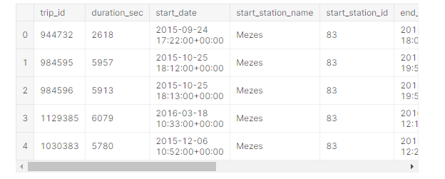
Each row of the table corresponds to a different bike trip, and we can use an analytic function to calculate the cumulative number of trips for each date in 2015.
In [2]:
# Query to count the (cumulative) number of trips per day
num_trips_query = """
WITH trips_by_day AS
(
SELECT DATE(start_date) AS trip_date,
COUNT(*) as num_trips
FROM `bigquery-public-data.san_francisco.bikeshare_trips`
WHERE EXTRACT(YEAR FROM start_date) = 2015
GROUP BY trip_date
)
SELECT *,
SUM(num_trips)
OVER (
ORDER BY trip_date
ROWS BETWEEN UNBOUNDED PRECEDING AND CURRENT ROW
) AS cumulative_trips
FROM trips_by_day
"""

# Run the query, and return a pandas DataFrame
num_trips_result = client.query(num_trips_query).result().to_dataframe()
num_trips_result.head()
Out[2]:
 | trip_date | num_trips | cumulative_trips
0 | 2015-01-01 | 181 | 181
1 | 2015-01-02 | 428 | 609
2 | 2015-01-03 | 283 | 892
3 | 2015-01-04 | 206 | 1098
4 | 2015-01-05 | 1186 | 2284
The query uses a common table expression (CTE) to first calculate the daily number of trips. Then, we use SUM() as an aggregate function.
- Since there is no PARTITION BY clause, the entire table is treated as a single partition.
- The ORDER BY clause orders the rows by date, where earlier dates appear first.
- By setting the window frame clause to ROWS BETWEEN UNBOUNDED PRECEDING AND CURRENT ROW, we ensure that all rows up to and including the current date are used to calculate the (cumulative) sum. (Note: If you read the documentation, you'll see that this is the default behavior, and so the query would return the same result if we left out this window frame clause.)
The next query tracks the stations where each bike began (in start_station_id) and ended (in end_station_id) the day on October 25, 2015.
In [3]:
# Query to track beginning and ending stations on October 25, 2015, for each bike
start_end_query = """
SELECT bike_number,
TIME(start_date) AS trip_time,
FIRST_VALUE(start_station_id)
OVER (
PARTITION BY bike_number
ORDER BY start_date
ROWS BETWEEN UNBOUNDED PRECEDING AND UNBOUNDED FOLLOWING
) AS first_station_id,
LAST_VALUE(end_station_id)
OVER (
PARTITION BY bike_number
ORDER BY start_date
ROWS BETWEEN UNBOUNDED PRECEDING AND UNBOUNDED FOLLOWING
) AS last_station_id,
start_station_id,
end_station_id
FROM `bigquery-public-data.san_francisco.bikeshare_trips`
WHERE DATE(start_date) = '2015-10-25'
"""

# Run the query, and return a pandas DataFrame
start_end_result = client.query(start_end_query).result().to_dataframe()
start_end_result.head()
Out[3]:
 | bike_number | trip_time | first_station_id | last_station_id | start_station_id | end_station_id
0 | 22 | 13:25:00 | 2 | 16 | 2 | 16
1 | 25 | 11:43:00 | 77 | 51 | 77 | 60
2 | 25 | 12:14:00 | 77 | 51 | 60 | 51
3 | 29 | 14:59:00 | 46 | 74 | 46 | 60
4 | 29 | 21:23:00 | 46 | 74 | 60 | 74
The query uses both FIRST_VALUE() and LAST_VALUE() as analytic functions.
- The PARTITION BY clause breaks the data into partitions based on the bike_number column. Since this column holds unique identifiers for the bikes, this ensures the calculations are performed separately for each bike.
- The ORDER BY clause puts the rows within each partition in chronological order.
- Since the window frame clause is ROWS BETWEEN UNBOUNDED PRECEDING AND UNBOUNDED FOLLOWING, for each row, its entire partition is used to perform the calculation. (This ensures the calculated values for rows in the same partition are identical.)

2.2 EXERCICES

Introduction
Here, you'll use window functions to answer questions about the Chicago Taxi Trips dataset.
Before you get started, run the code cell below to set everything up.

The following code cell fetches the taxi_trips table from the chicago_taxi_trips dataset. We also preview the first five rows of the table. You'll use the table to answer the questions below.

from google.cloud import bigquery

# Create a "Client" object
client = bigquery.Client()

# Construct a reference to the "chicago_taxi_trips" dataset
dataset_ref = client.dataset("chicago_taxi_trips", project="bigquery-public-data")

# API request - fetch the dataset
dataset = client.get_dataset(dataset_ref)

# Construct a reference to the "taxi_trips" table
table_ref = dataset_ref.table("taxi_trips")

# API request - fetch the table
table = client.get_table(table_ref)

# Preview the first five lines of the table
client.list_rows(table, max_results=5).to_dataframe()

Exercises

1) How can you predict the demand for taxis?
Say you work for a taxi company, and you're interested in predicting the demand for taxis. Towards this goal, you'd like to create a plot that shows a rolling average of the daily number of taxi trips. Amend the (partial) query below to return a DataFrame with two columns:
- trip_date - contains one entry for each date from January 1, 2016, to December 31, 2017.
- avg_num_trips - shows the average number of daily trips, calculated over a window including the value for the current date, along with the values for the preceding 15 days and the following 15 days, as long as the days fit within the two-year time frame. For instance, when calculating the value in this column for January 5, 2016, the window will include the number of trips for the preceding 4 days, the current date, and the following 15 days.
This query is partially completed for you, and you need only write the part that calculates the avg_num_trips column. Note that this query uses a common table expression (CTE); if you need to review how to use CTEs, you're encouraged to check out this tutorial in the Intro to SQL micro-course.

# Fill in the blank below
avg_num_trips_query = """
WITH trips_by_day AS
(
SELECT DATE(trip_start_timestamp) AS trip_date,
COUNT(*) as num_trips
FROM `bigquery-public-data.chicago_taxi_trips.taxi_trips`
WHERE trip_start_timestamp >= '2016-01-01' AND trip_start_timestamp < '2018-01-01'
GROUP BY trip_date
ORDER BY trip_date
)
SELECT trip_date,
AVG(num_trips)
OVER (
ORDER BY trip_date
ROWS BETWEEN 15 PRECEDING AND 15 FOLLOWING
) AS avg_num_trips
FROM trips_by_day
"""
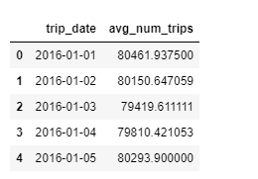
Hint: Use the AVG() function. Write an OVER clause with that orders the rows with the trip_date column and uses a window that includes the 15 preceding rows, the current row, and the following 15 rows.
Solution:

avg_num_trips_query = """
WITH trips_by_day AS
(
SELECT DATE(trip_start_timestamp) AS trip_date,
COUNT(*) as num_trips
FROM `bigquery-public-data.chicago_taxi_trips.taxi_trips`
WHERE trip_start_timestamp >= '2016-01-01' AND trip_start_timestamp < '2018-01-01'
GROUP BY trip_date
ORDER BY trip_date
)
SELECT trip_date,
AVG(num_trips)
OVER (
ORDER BY trip_date
ROWS BETWEEN 15 PRECEDING AND 15 FOLLOWING
) AS avg_num_trips
FROM trips_by_day
"""

2) Can you separate and order trips by community area?
The query below returns a DataFrame with three columns from the table: pickup_community_area, trip_start_timestamp, and trip_end_timestamp.
Amend the query to return an additional column called trip_number which shows the order in which the trips were taken from their respective community areas. So, the first trip of the day originating from community area 1 should receive a value of 1; the second trip of the day from the same area should receive a value of 2. Likewise, the first trip of the day from community area 2 should receive a value of 1, and so on.
Note that there are many numbering functions that can be used to solve this problem (depending on how you want to deal with trips that started at the same time from the same community area); to answer this question, please use the RANK() function.

# Amend the query below
trip_number_query = """
SELECT pickup_community_area,
trip_start_timestamp,
trip_end_timestamp,
RANK()
OVER (
PARTITION BY pickup_community_area
ORDER BY trip_start_timestamp
) AS trip_number
FROM `bigquery-public-data.chicago_taxi_trips.taxi_trips`
WHERE DATE(trip_start_timestamp) = '2017-05-01'
"""
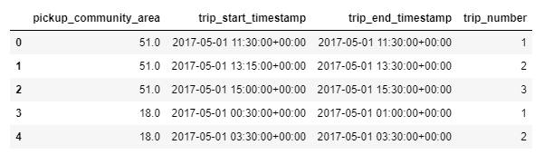

Hint: You don't need a GROUP BY clause. Use the RANK() function. Your OVER clause should order the rows by the trip_start_timestamp column and break the data into partitions based on pickup_community_area.
Solution:

trip_number_query = """
SELECT pickup_community_area,
trip_start_timestamp,
trip_end_timestamp,
RANK()
OVER (
PARTITION BY pickup_community_area
ORDER BY trip_start_timestamp
) AS trip_number
FROM `bigquery-public-data.chicago_taxi_trips.taxi_trips`
WHERE DATE(trip_start_timestamp) = '2017-05-01'
"""

trip_number_result = client.query(trip_number_query).result().to_dataframe()

3) How much time elapses between trips?
The (partial) query in the code cell below shows, for each trip in the selected time frame, the corresponding taxi_id, trip_start_timestamp, and trip_end_timestamp.
Your task in this exercise is to edit the query to include an additional prev_break column that shows the length of the break (in minutes) that the driver had before each trip started (this corresponds to the time between trip_start_timestamp of the current trip and trip_end_timestamp of the previous trip). Partition the calculation by taxi_id, and order the results within each partition by trip_start_timestamp.
Some sample results are shown below, where all rows correspond to the same driver (or taxi_id). Take the time now to make sure that the values in the prev_break column make sense to you!
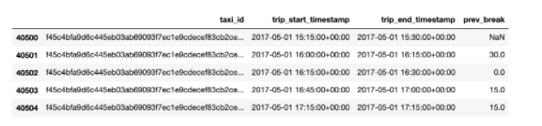
Note that the first trip of the day for each driver should have a value of NaN (not a number) in the prev_break column.

# Fill in the blanks below
reak_time_query = """
SELECT taxi_id,
trip_start_timestamp,
trip_end_timestamp,
TIMESTAMP_DIFF(
trip_start_timestamp,
LAG(trip_end_timestamp, 1) OVER (PARTITION BY taxi_id ORDER BY trip_start_timestamp),
MINUTE) as prev_break
FROM `bigquery-public-data.chicago_taxi_trips.taxi_trips`
WHERE DATE(trip_start_timestamp) = '2017-05-01'
"""

# break_time_result = client.query(break_time_query).result().to_dataframe()

Hint: The TIMESTAMP_DIFF() function takes three arguments, where the first (trip_start_timestamp) and the last (MINUTE) are provided for you. This function provides the time difference (in minutes) of the timestamps in the first two arguments. You need only fill in the second argument, which should use the LAG() function to pull the timestamp corresponding to the end of the previous trip (for the same taxi_id).
Solution:

break_time_query = """
SELECT taxi_id,
trip_start_timestamp,
trip_end_timestamp,
TIMESTAMP_DIFF(
trip_start_timestamp,
LAG(trip_end_timestamp, 1) OVER (PARTITION BY taxi_id ORDER BY trip_start_timestamp),
MINUTE) as prev_break
FROM `bigquery-public-data.chicago_taxi_trips.taxi_trips`
WHERE DATE(trip_start_timestamp) = '2017-05-01'
"""

break_time_result = client.query(break_time_query).result().to_dataframe()

3. Nested and Repeated Data

3.1 COURS

Introduction
So far, you've worked with many types of data, including numeric types (integers, floating point values), strings, and the DATETIME type. In this tutorial, you'll learn how to query nested and repeated data. These are the most complex data types that you can find in BigQuery datasets!

Nested data
Consider a hypothetical dataset containing information about pets and their toys. We could organize this information in two different tables (a pets table and a toys table). The toys table could contain a "Pet_ID" column that could be used to match each toy to the pet that owns it.
Another option in BigQuery is to organize all of the information in a single table, similar to the pets_and_toys table below.

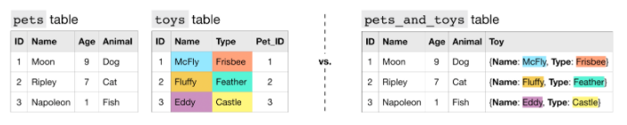
In this case, all of the information from the toys table is collapsed into a single column (the "Toy" column in the pets_and_toys table). We refer to the "Toy" column in the pets_and_toys table as a nested column, and say that the "Name" and "Type" fields are nested inside of it.
Nested columns have type STRUCT (or type RECORD). This is reflected in the table schema below.
Recall that we refer to the structure of a table as its schema. If you need to review how to interpret table schema, feel free to check out this lesson from the Intro to SQL micro-course.
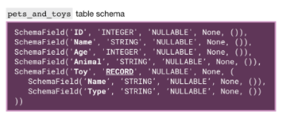
To query a column with nested data, we need to identify each field in the context of the column that contains it:
- Toy.Name refers to the "Name" field in the "Toy" column, and
- Toy.Type refers to the "Type" field in the "Toy" column.
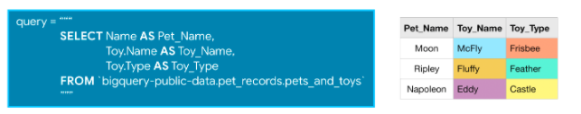
Otherwise, our usual rules remain the same - we need not change anything else about our queries.

Repeated data
Now consider the (more realistic!) case where each pet can have multiple toys. In this case, to collapse this information into a single table, we need to leverage a different datatype.
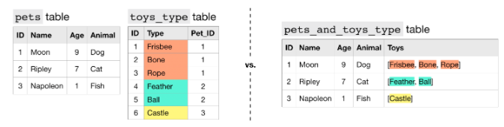
We say that the "Toys" column contains repeated data, because it permits more than one value for each row. This is reflected in the table schema below, where the mode of the "Toys" column appears as 'REPEATED'.
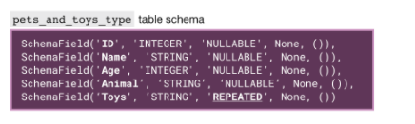
Each entry in a repeated field is an ARRAY, or an ordered list of (zero or more) values with the same datatype. For instance, the entry in the "Toys" column for Moon the Dog is [Frisbee, Bone, Rope], which is an ARRAY with three values.
When querying repeated data, we need to put the name of the column containing the repeated data inside an UNNEST() function.
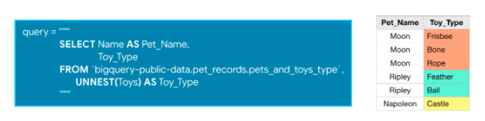
This essentially flattens the repeated data (which is then appended to the right side of the table) so that we have one element on each row. For an illustration of this, check out the image below.

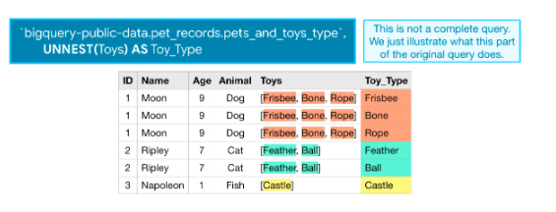
Nested and repeated data
Now, what if pets can have multiple toys, and we'd like to keep track of both the name and type of each toy? In this case, we can make the "Toys" column both nested and repeated.
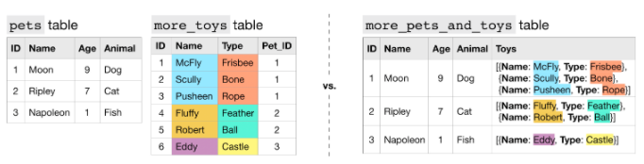
In the more_pets_and_toys table above, "Name" and "Type" are both fields contained within the "Toys" STRUCT, and each entry in both "Toys.Name" and "Toys.Type" is an ARRAY.
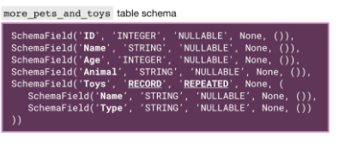
Let's look at a sample query.
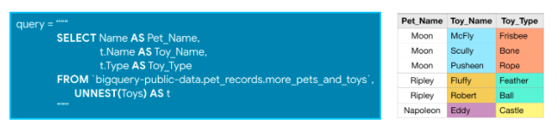
Since the "Toys" column is repeated, we flatten it with the UNNEST() function. And, since we give the flattened column an alias of t, we can refer to the "Name" and "Type" fields in the "Toys" column as t.Name and t.Type, respectively.
To reinforce what you've learned, we'll apply these ideas to a real dataset in the section below.

Example
We'll work with the Google Analytics Sample dataset. It contains information tracking the behavior of visitors to the Google Merchandise store, an e-commerce website that sells Google branded items.
We begin by printing the first few rows of the ga_sessions_20170801 table. (We have hidden the corresponding code. To take a peek, click on the "Code" button below.) This table tracks visits to the website on August 1, 2017.
Code
Using Kaggle's public dataset BigQuery integration.
Out[1]:
 | visitorId | visitNumber | visitId | visitStartTime | date | totals | trafficSource | device | geoNetwork | customDimensions | hits | fullVisitorId | userId | clientId | channelGrouping | socialEngagementType
0 | None | 1 | 1501583974 | 1501583974 | 20170801 | {'visits': 1, 'hits': 1, 'pageviews': 1, 'time... | {'referralPath': None, 'campaign': '(not set)'... | {'browser': 'Chrome', 'browserVersion': 'not a... | {'continent': 'Americas', 'subContinent': 'Car... | [] | [{'hitNumber': 1, 'time': 0, 'hour': 3, 'minut... | 2248281639583218707 | None | None | Organic Search | Not Socially Engaged
1 | None | 1 | 1501616585 | 1501616585 | 20170801 | {'visits': 1, 'hits': 1, 'pageviews': 1, 'time... | {'referralPath': None, 'campaign': '(not set)'... | {'browser': 'Chrome', 'browserVersion': 'not a... | {'continent': 'Americas', 'subContinent': 'Nor... | [{'index': 4, 'value': 'North America'}] | [{'hitNumber': 1, 'time': 0, 'hour': 12, 'minu... | 8647436381089107732 | None | None | Organic Search | Not Socially Engaged
2 | None | 1 | 1501583344 | 1501583344 | 20170801 | {'visits': 1, 'hits': 1, 'pageviews': 1, 'time... | {'referralPath': None, 'campaign': '(not set)'... | {'browser': 'Chrome', 'browserVersion': 'not a... | {'continent': 'Asia', 'subContinent': 'Souther... | [{'index': 4, 'value': 'APAC'}] | [{'hitNumber': 1, 'time': 0, 'hour': 3, 'minut... | 2055839700856389632 | None | None | Organic Search | Not Socially Engaged
3 | None | 1 | 1501573386 | 1501573386 | 20170801 | {'visits': 1, 'hits': 1, 'pageviews': 1, 'time... | {'referralPath': None, 'campaign': '(not set)'... | {'browser': 'Chrome', 'browserVersion': 'not a... | {'continent': 'Europe', 'subContinent': 'Weste... | [{'index': 4, 'value': 'EMEA'}] | [{'hitNumber': 1, 'time': 0, 'hour': 0, 'minut... | 0750846065342433129 | None | None | Direct | Not Socially Engaged
4 | None | 8 | 1501651467 | 1501651467 | 20170801 | {'visits': 1, 'hits': 1, 'pageviews': 1, 'time... | {'referralPath': None, 'campaign': '(not set)'... | {'browser': 'Chrome', 'browserVersion': 'not a... | {'continent': 'Americas', 'subContinent': 'Nor... | [{'index': 4, 'value': 'North America'}] | [{'hitNumber': 1, 'time': 0, 'hour': 22, 'minu... | 0573427169410921198 | None | None | Organic Search | Not Socially Engaged
For a description of each field, refer to this data dictionary.
The table has many nested fields, which you can verify by looking at either the data dictionary (hint: search for appearances of 'RECORD' on the page) or the table preview above.
In our first query against this table, we'll work with the "totals" and "device" columns.
Code
SCHEMA field for the 'totals' column:

SchemaField('totals', 'RECORD', 'NULLABLE', None, (SchemaField('visits', 'INTEGER', 'NULLABLE', None, ()), SchemaField('hits', 'INTEGER', 'NULLABLE', None, ()), SchemaField('pageviews', 'INTEGER', 'NULLABLE', None, ()), SchemaField('timeOnSite', 'INTEGER', 'NULLABLE', None, ()), SchemaField('bounces', 'INTEGER', 'NULLABLE', None, ()), SchemaField('transactions', 'INTEGER', 'NULLABLE', None, ()), SchemaField('transactionRevenue', 'INTEGER', 'NULLABLE', None, ()), SchemaField('newVisits', 'INTEGER', 'NULLABLE', None, ()), SchemaField('screenviews', 'INTEGER', 'NULLABLE', None, ()), SchemaField('uniqueScreenviews', 'INTEGER', 'NULLABLE', None, ()), SchemaField('timeOnScreen', 'INTEGER', 'NULLABLE', None, ()), SchemaField('totalTransactionRevenue', 'INTEGER', 'NULLABLE', None, ()), SchemaField('sessionQualityDim', 'INTEGER', 'NULLABLE', None, ())))

SCHEMA field for the 'device' column:

SchemaField('device', 'RECORD', 'NULLABLE', None, (SchemaField('browser', 'STRING', 'NULLABLE', None, ()), SchemaField('browserVersion', 'STRING', 'NULLABLE', None, ()), SchemaField('browserSize', 'STRING', 'NULLABLE', None, ()), SchemaField('operatingSystem', 'STRING', 'NULLABLE', None, ()), SchemaField('operatingSystemVersion', 'STRING', 'NULLABLE', None, ()), SchemaField('isMobile', 'BOOLEAN', 'NULLABLE', None, ()), SchemaField('mobileDeviceBranding', 'STRING', 'NULLABLE', None, ()), SchemaField('mobileDeviceModel', 'STRING', 'NULLABLE', None, ()), SchemaField('mobileInputSelector', 'STRING', 'NULLABLE', None, ()), SchemaField('mobileDeviceInfo', 'STRING', 'NULLABLE', None, ()), SchemaField('mobileDeviceMarketingName', 'STRING', 'NULLABLE', None, ()), SchemaField('flashVersion', 'STRING', 'NULLABLE', None, ()), SchemaField('javaEnabled', 'BOOLEAN', 'NULLABLE', None, ()), SchemaField('language', 'STRING', 'NULLABLE', None, ()), SchemaField('screenColors', 'STRING', 'NULLABLE', None, ()), SchemaField('screenResolution', 'STRING', 'NULLABLE', None, ()), SchemaField('deviceCategory', 'STRING', 'NULLABLE', None, ())))
We refer to the "browser" field (which is nested in the "device" column) and the "transactions" field (which is nested inside the "totals" column) as device.browser and totals.transactions in the query below:
In [3]:
# Query to count the number of transactions per browser
query = """
SELECT device.browser AS device_browser,
SUM(totals.transactions) as total_transactions
FROM `bigquery-public-data.google_analytics_sample.ga_sessions_20170801`
GROUP BY device_browser
ORDER BY total_transactions DESC
"""

# Run the query, and return a pandas DataFrame
result = client.query(query).result().to_dataframe()
result.head()
Out[3]:
 | device_browser | total_transactions
0 | Chrome | 41.0
1 | Safari | 3.0
2 | Firefox | 1.0
3 | Internet Explorer | NaN
4 | UC Browser | NaN
By storing the information in the "device" and "totals" columns as STRUCTs (as opposed to separate tables), we avoid expensive JOINs. This increases performance and keeps us from having to worry about JOIN keys (and which tables have the exact data we need).
Now we'll work with the "hits" column as an example of data that is both nested and repeated. Since:
- "hits" is a STRUCT (contains nested data) and is repeated,
- "hitNumber", "page", and "type" are all nested inside the "hits" column, and
- "pagePath" is nested inside the "page" field,
we can query these fields with the following syntax:
In [4]:
# Query to determine most popular landing point on the website
query = """
SELECT hits.page.pagePath as path,
COUNT(hits.page.pagePath) as counts
FROM `bigquery-public-data.google_analytics_sample.ga_sessions_20170801`,
UNNEST(hits) as hits
WHERE hits.type="PAGE" and hits.hitNumber=1
GROUP BY path
ORDER BY counts DESC
"""

# Run the query, and return a pandas DataFrame
result = client.query(query).result().to_dataframe()
result.head()
Out[4]:
 | path | counts
0 | /home | 1257
1 | /google+redesign/shop+by+brand/youtube | 587
2 | /google+redesign/apparel/mens/mens+t+shirts | 117
3 | /signin.html | 78
4 | /basket.html | 35
In this case, most users land on the website through the "/home" page.

3.2 EXERCICES

Introduction
Now that you know how to query nested and repeated data, you're ready to draw interesting insights from the GitHub Repos dataset.

Exercises

1) Who had the most commits in 2016?
GitHub is the most popular place to collaborate on software projects. A GitHub repository (or repo) is a collection of files associated with a specific project, and a GitHub commit is a change that a user has made to a repository. We refer to the user as a committer.
The sample_commits table contains a small sample of GitHub commits, where each row corresponds to different commit. The code cell below fetches the table and shows the first five rows of this table.

from google.cloud import bigquery

# Create a "Client" object
client = bigquery.Client()

# Construct a reference to the "github_repos" dataset
dataset_ref = client.dataset("github_repos", project="bigquery-public-data")

# API request - fetch the dataset
dataset = client.get_dataset(dataset_ref)

# Construct a reference to the "sample_commits" table
table_ref = dataset_ref.table("sample_commits")

# API request - fetch the table
sample_commits_table = client.get_table(table_ref)

# Preview the first five lines of the table
client.list_rows(sample_commits_table, max_results=5).to_dataframe()

commit | tree | parent | author | committer | subject | message | trailer | difference | difference_truncated | repo_name | encoding
0 | 3eca86e75ec7a7d4b9a9c8091b11676f7bd2a39f | 8e1b4380409a85a922ee0d3f622b5dd4d16bcfad | [104a0c02e8b1936c049e18a6d4e4ab040fb61213] | {'name': 'Mark Rutland', 'email': '1db9dd262be... | {'name': 'Catalin Marinas', 'email': '15ce75b2... | arm64: Remove fixmap include fragility | arm64: Remove fixmap include fragility\n\nThe ... | [{'key': 'Signed-off-by', 'value': 'Mark Rutla... | [{'old_mode': 33188, 'new_mode': 33188, 'old_p... | None | torvalds/linux | None
1 | 7158627686f02319c50c8d9d78f75d4c8d126ff2 | 3b4d781bd966f07cad1b67b137f0ff8b89430e9a | [66aa8d6a145b6a66566b4fce219cc56c3d0e01c3] | {'name': 'Will Deacon', 'email': 'b913f13ef92a... | {'name': 'Catalin Marinas', 'email': '15ce75b2... | arm64: percpu: implement optimised pcpu access... | arm64: percpu: implement optimised pcpu access... | [{'key': 'Signed-off-by', 'value': 'Will Deaco... | [{'old_mode': 33188, 'new_mode': 33188, 'old_p... | None | torvalds/linux | None
2 | 9732cafd9dc0206479be919baf0067239f0a63ca | c8878035ac9cb6dce592957f12dc1723a583989d | [f3c003f72dfb2497056bcbb864885837a1968ed5] | {'name': 'Jiang Liu', 'email': 'c745fa7b96fe79... | {'name': 'Catalin Marinas', 'email': '15ce75b2... | arm64, jump label: optimize jump label impleme... | arm64, jump label: optimize jump label impleme... | [{'key': 'Reviewed-by', 'value': 'Will Deacon ... | [{'old_mode': 33188, 'new_mode': 33188, 'old_p... | None | torvalds/linux | None
3 | 4702abd3f9728893ad5b0f4389e1902588510459 | 32926e7c55ef585d9b9c174a0e5f9ed13ed6bf7e | [ddf28352b80c86754a6424e3a61e8bdf9213b3c7] | {'name': 'Nicolas Pitre', 'email': '408789a210... | {'name': 'Arnd Bergmann', 'email': 'f2c659f019... | ARM: mach-nuc93x: delete | ARM: mach-nuc93x: delete\n\nThis architecture ... | [{'key': 'Signed-off-by', 'value': 'Nicolas Pi... | [{'old_mode': 33188, 'new_mode': 33188, 'old_p... | None | torvalds/linux | None
4 | 57bd4b91a6cfc5bad4c5d829ef85293ea63643ea | 2ffc2066eb7638e185663e9d849663403229d4e5

# Print information on all the columns in the table
sample_commits_table.schema
[SchemaField('commit', 'STRING', 'NULLABLE', None, ()),
SchemaField('tree', 'STRING', 'NULLABLE', None, ()),
SchemaField('parent', 'STRING', 'REPEATED', None, ()),
SchemaField('author', 'RECORD', 'NULLABLE', None, (SchemaField('name', 'STRING', 'NULLABLE', None, ()), SchemaField('email', 'STRING', 'NULLABLE', None, ()), SchemaField('time_sec', 'INTEGER', 'NULLABLE', None, ()), SchemaField('tz_offset', 'INTEGER', 'NULLABLE', None, ()), SchemaField('date', 'TIMESTAMP', 'NULLABLE', None, ()))),
SchemaField('committer', 'RECORD', 'NULLABLE', None, (SchemaField('name', 'STRING', 'NULLABLE', None, ()), SchemaField('email', 'STRING', 'NULLABLE', None, ()), SchemaField('time_sec', 'INTEGER', 'NULLABLE', None, ()), SchemaField('tz_offset', 'INTEGER', 'NULLABLE', None, ()), SchemaField('date', 'TIMESTAMP', 'NULLABLE', None, ()))),
SchemaField('subject', 'STRING', 'NULLABLE', None, ()),
SchemaField('message', 'STRING', 'NULLABLE', None, ()),
SchemaField('trailer', 'RECORD', 'REPEATED', None, (SchemaField('key', 'STRING', 'NULLABLE', None, ()), SchemaField('value', 'STRING', 'NULLABLE', None, ()), SchemaField('email', 'STRING', 'NULLABLE', None, ()))),
SchemaField('difference', 'RECORD', 'REPEATED', None, (SchemaField('old_mode', 'INTEGER', 'NULLABLE', None, ()), SchemaField('new_mode', 'INTEGER', 'NULLABLE', None, ()), SchemaField('old_path', 'STRING', 'NULLABLE', None, ()), SchemaField('new_path', 'STRING', 'NULLABLE', None, ()), SchemaField('old_sha1', 'STRING', 'NULLABLE', None, ()), SchemaField('new_sha1', 'STRING', 'NULLABLE', None, ()), SchemaField('old_repo', 'STRING', 'NULLABLE', None, ()), SchemaField('new_repo', 'STRING', 'NULLABLE', None, ()))),
SchemaField('difference_truncated', 'BOOLEAN', 'NULLABLE', None, ()),
SchemaField('repo_name', 'STRING', 'NULLABLE', None, ()),
SchemaField('encoding', 'STRING', 'NULLABLE', None, ())]

Write a query to find the individuals with the most commits in this table in 2016. Your query should return a table with two columns:
- committer_name - contains the name of each individual with a commit (from 2016) in the table
- num_commits - shows the number of commits the individual has in the table (from 2016)
Sort the table, so that people with more commits appear first.
NOTE: You can find the name of each committer and the date of the commit under the "committer" column, in the "name" and "date" child fields, respectively.

# Write a query to find the answer
max_commits_query = """
SELECT committer.name AS committer_name, COUNT(*) AS num_commits
FROM `bigquery-public-data.github_repos.sample_commits`
WHERE committer.date >= '2016-01-01' AND committer.date < '2017-01-01'
GROUP BY committer_name
ORDER BY num_commits DESC
"""

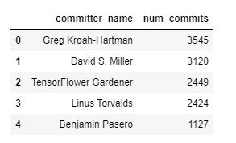
Hint: Use committer.name and committer.date in a query to count the number of rows corresponding to each committer in 2016. Use a WHERE clause, a GROUP BY clause, and an ORDER BY clause.
Solution:

max_commits_query = """
SELECT committer.name AS committer_name, COUNT(*) AS num_commits
FROM `bigquery-public-data.github_repos.sample_commits`
WHERE committer.date >= '2016-01-01' AND committer.date < '2017-01-01'
GROUP BY committer_name
ORDER BY num_commits DESC
"""

2) Look at languages!
Now you will work with the languages table. Run the code cell below to print the first few rows.

table_ref = dataset_ref.table("languages")

# API request - fetch the table
languages_table = client.get_table(table_ref)

# Preview the first five lines of the table
client.list_rows(languages_table, max_results=5).to_dataframe()

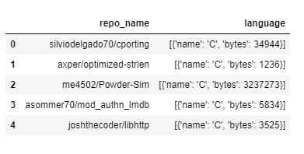
Each row of the languages table corresponds to a different repository.
- The "repo_name" column contains the name of the repository,
- the "name" field in the "language" column contains the programming languages that can be found in the repo, and
- the "bytes" field in the "language" column has the size of the files (in bytes, for the corresponding language).
Run the following code cell to print the table schema.

# Print information on all the columns in the table
languages_table.schema

[SchemaField('repo_name', 'STRING', 'NULLABLE', None, ()),
SchemaField('language', 'RECORD', 'REPEATED', None, (SchemaField('name', 'STRING', 'NULLABLE', None, ()), SchemaField('bytes', 'INTEGER', 'NULLABLE', None, ())))]
Assume for the moment that you have access to a table called sample_languages that contains only a very small subset of the rows from the languages table: in fact, it contains only three rows! This table is depicted in the image below.
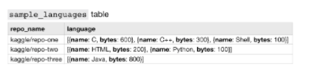

How many rows are in the table returned by the query below?

Fill in your answer in the next code cell.

# Fill in the blank
num_rows = 6

Hint: Remember that the UNNEST() function essentially flattens the repeated data (which is then appended to the right side of the table) so that we have one element on each row.
Solution:

num_rows = 6

3) What's the most popular programming language?
Write a query to leverage the information in the languages table to determine which programming languages appear in the most repositories. The table returned by your query should have two columns:
- language_name - the name of the programming language
- num_repos - the number of repositories in the languages table that use the programming language
Sort the table so that languages that appear in more repos are shown first.

# Write a query to find the answer
pop_lang_query = """
SELECT l.name as language_name, COUNT(*) as num_repos
FROM `bigquery-public-data.github_repos.languages`,
UNNEST(language) AS l
GROUP BY language_name
ORDER BY num_repos DESC
"""
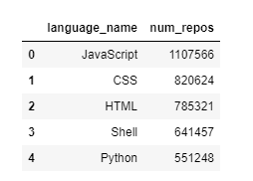
Hint: The "language" column contains repeated data!
Solution:

pop_lang_query = """
SELECT l.name as language_name, COUNT(*) as num_repos
FROM `bigquery-public-data.github_repos.languages`,
UNNEST(language) AS l
GROUP BY language_name
ORDER BY num_repos DESC
"""

4) Which languages are used in the repository with the most languages?
For this question, you'll restrict your attention to the repository with name 'polyrabbit/polyglot'.
Write a query that returns a table with one row for each language in this repository. The table should have two columns:
- name - the name of the programming language
- bytes - the total number of bytes of that programming language
Sort the table by the bytes column so that programming languages that take up more space in the repo appear first.

# Your code here
all_langs_query = """
SELECT l.name, l.bytes
FROM `bigquery-public-data.github_repos.languages`,
UNNEST(language) as l
WHERE repo_name = 'polyrabbit/polyglot'
ORDER BY l.bytes DESC
"""

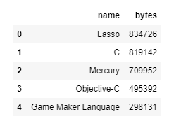

Hint: The "language" column contains repeated data! You'll need to use a WHERE clause and an ORDER BY clause.

Solution:

all_langs_query = """
SELECT l.name, l.bytes
FROM `bigquery-public-data.github_repos.languages`,
UNNEST(language) as l
WHERE repo_name = 'polyrabbit/polyglot'
ORDER BY l.bytes DESC
"""

4. Writing Efficient Queries

4.1 COURS

Introduction
Sometimes it doesn't matter whether your query is efficient or not. For example, you might write a query you expect to run only once, and it might be working on a small dataset. In this case, anything that gives you the answer you need will do.
But what about queries that will be run many times, like a query that feeds data to a website? Those need to be efficient so you don't leave users waiting for your website to load.
Or what about queries on huge datasets? These can be slow and cost a business a lot of money if they are written poorly.
Most database systems have a query optimizer that attempts to interpret/execute your query in the most effective way possible. But several strategies can still yield huge savings in many cases.

Some useful functions
We will use two functions to compare the efficiency of different queries:
- show_amount_of_data_scanned() shows the amount of data the query uses.
- show_time_to_run() prints how long it takes for the query to execute.
Code
Using Kaggle's public dataset BigQuery integration.

Strategies

1) Only select the columns you want.
It is tempting to start queries with SELECT * FROM .... It's convenient because you don't need to think about which columns you need. But it can be very inefficient.
This is especially important if there are text fields that you don't need, because text fields tend to be larger than other fields.
In [2]:
star_query = "SELECT * FROM `bigquery-public-data.github_repos.contents`"
show_amount_of_data_scanned(star_query)

basic_query = "SELECT size, binary FROM `bigquery-public-data.github_repos.contents`"
show_amount_of_data_scanned(basic_query)
Data processed: 2523.552 GB
Data processed: 2.412 GB
In this case, we see a 1000X reduction in data being scanned to complete the query, because the raw data contained a text field that was 1000X larger than the fields we might need.

2) Read less data.
Both queries below calculate the average duration (in seconds) of one-way bike trips in the city of San Francisco.
In [3]:
more_data_query = """
SELECT MIN(start_station_name) AS start_station_name,
MIN(end_station_name) AS end_station_name,
AVG(duration_sec) AS avg_duration_sec
FROM `bigquery-public-data.san_francisco.bikeshare_trips`
WHERE start_station_id != end_station_id
GROUP BY start_station_id, end_station_id
LIMIT 10
"""
show_amount_of_data_scanned(more_data_query)

less_data_query = """
SELECT start_station_name,
end_station_name,
AVG(duration_sec) AS avg_duration_sec
FROM `bigquery-public-data.san_francisco.bikeshare_trips`
WHERE start_station_name != end_station_name
GROUP BY start_station_name, end_station_name
LIMIT 10
"""
show_amount_of_data_scanned(less_data_query)
Data processed: 0.076 GB
Data processed: 0.06 GB
Since there is a 1:1 relationship between the station ID and the station name, we don't need to use the start_station_id and end_station_id columns in the query. By using only the columns with the station IDs, we scan less data.

3) Avoid N:N JOINs.
Most of the JOINs that you have executed in this course have been 1:1 JOINs. In this case, each row in each table has at most one match in the other table.
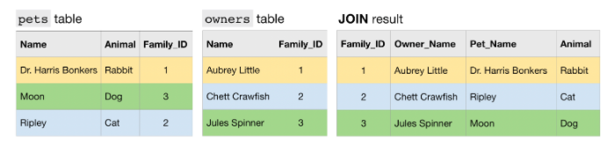
Another type of JOIN is an N:1 JOIN. Here, each row in one table matches potentially many rows in the other table.

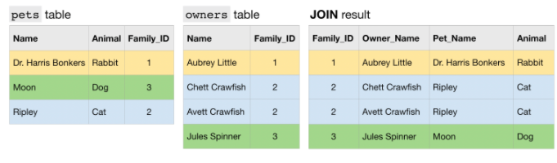
Finally, an N:N JOIN is one where a group of rows in one table can match a group of rows in the other table. Note that in general, all other things equal, this type of JOIN produces a table with many more rows than either of the two (original) tables that are being JOINed.
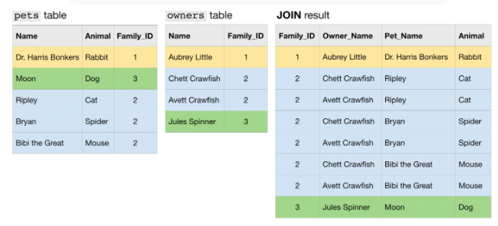
Now we'll work with an example from a real dataset. Both examples below count the number of distinct committers and the number of files in several GitHub repositories.
In [4]:
big_join_query = """
SELECT repo,
COUNT(DISTINCT c.committer.name) as num_committers,
COUNT(DISTINCT f.id) AS num_files
FROM `bigquery-public-data.github_repos.commits` AS c,
UNNEST(c.repo_name) AS repo
INNER JOIN `bigquery-public-data.github_repos.files` AS f
ON f.repo_name = repo
WHERE f.repo_name IN ( 'tensorflow/tensorflow', 'facebook/react', 'twbs/bootstrap', 'apple/swift', 'Microsoft/vscode', 'torvalds/linux')
GROUP BY repo
ORDER BY repo
"""
show_time_to_run(big_join_query)

small_join_query = """
WITH commits AS
(
SELECT COUNT(DISTINCT committer.name) AS num_committers, repo
FROM `bigquery-public-data.github_repos.commits`,
UNNEST(repo_name) as repo
WHERE repo IN ( 'tensorflow/tensorflow', 'facebook/react', 'twbs/bootstrap', 'apple/swift', 'Microsoft/vscode', 'torvalds/linux')
GROUP BY repo
),
files AS
(
SELECT COUNT(DISTINCT id) AS num_files, repo_name as repo
FROM `bigquery-public-data.github_repos.files`
WHERE repo_name IN ( 'tensorflow/tensorflow', 'facebook/react', 'twbs/bootstrap', 'apple/swift', 'Microsoft/vscode', 'torvalds/linux')
GROUP BY repo
)
SELECT commits.repo, commits.num_committers, files.num_files
FROM commits
INNER JOIN files
ON commits.repo = files.repo
ORDER BY repo
"""

show_time_to_run(small_join_query)
Time to run: 1272.855 seconds
Time to run: 4.494 seconds
The first query has a large N:N JOIN. By rewriting the query to decrease the size of the JOIN, we see it runs much faster.

Learn more
These strategies and many more are discussed in this thorough guide to Google BigQuery. If you'd like to learn more about how to write more efficient queries (or deepen your knowledge of all things BigQuery), you're encouraged to check it out!

4.2 EXERCICES

Introduction
Now, you'll use what you learned in the previous tutorial to improve the efficiency of several queries.

Exercises

1) You work for Pet Costumes International.
You need to write three queries this afternoon. You have enough time to write working versions of all three, but only enough time to think about optimizing one of them. Which of these queries is most worth optimizing?
- A software engineer wrote an app for the shipping department, to see what items need to be shipped and which aisle of the warehouse to go to for those items. She wants you to write the query. It will involve data that is stored in an orders table, a shipments table and a warehouseLocation table. The employees in the shipping department will pull up this app on a tablet, hit refresh, and your query results will be shown in a nice interface so they can see what costumes to send where.
- The CEO wants a list of all customer reviews and complaints… which are conveniently stored in a single reviews table. Some of the reviews are really long… because people love your pirate costumes for parrots, and they can’t stop writing about how cute they are.
- Dog owners are getting more protective than ever. So your engineering department has made costumes with embedded GPS trackers and wireless communication devices. They send the costumes’ coordinates to your database once a second. You then have a website where owners can find the location of their dogs (or at least the costumes they have for those dogs). For this service to work, you need a query that shows the most recent location for all costumes owned by a given human. This will involve data in a CostumeLocations table as well as a CostumeOwners table.
So, which of these could benefit most from being written efficiently? Set the value of the query_to_optimize variable below to one of 1, 2, or 3. (Your answer should have type integer.)

# Fill in your answer
query_to_optimize = 3
Hint: Do the queries run on big or small datasets? Do they need to be run many times, or just once? Is the data spread over multiple tables, or contained in just one?
Solution: query_to_optimize = 3
Why 3: Because data is sent for each costume at each second, this is the query that is likely to involve the most data (by far). And it will be run on a recurring basis. So writing this well could pay off on a recurring basis.
Why not 1: This is the second most valuable query to optimize. It will be run on a recurring basis, and it involves merges, which is commonly a place where you can make your queries more efficient
Why not 2: This sounds like it will be run only one time. So, it probably doesn’t matter if it takes a few seconds extra or costs a few cents more to run that one time. Also, it doesn’t involve JOINs. While the data has text fields (the reviews), that is the data you need. So, you can’t leave these out of your select query to save computation.

2) Make it easier to find Mitzie!
You have the following two tables:

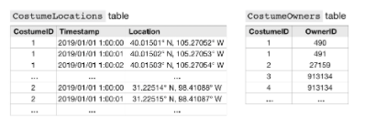
The CostumeLocations table shows timestamped GPS data for all of the pet costumes in the database, where CostumeID is a unique identifier for each costume.
The CostumeOwners table shows who owns each costume, where the OwnerID column contains unique identifiers for each (human) owner. Note that each owner can have more than one costume! And, each costume can have more than one owner: this allows multiple individuals from the same household (all with their own, unique OwnerID) to access the locations of their pets' costumes.
Say you need to use these tables to get the current location of one pet in particular: Mitzie the Dog recently ran off chasing a squirrel, but thankfully she was last seen in her hot dog costume!
One of Mitzie's owners (with owner ID MitzieOwnerID) logs into your website to pull the last locations of every costume in his possession. Currently, you get this information by running the following query:

WITH LocationsAndOwners AS
(
SELECT *
FROM CostumeOwners co INNER JOIN CostumeLocations cl
ON co.CostumeID = cl.CostumeID
),
LastSeen AS
(
SELECT CostumeID, MAX(Timestamp)
FROM LocationsAndOwners
GROUP BY CostumeID
)
SELECT lo.CostumeID, Location
FROM LocationsAndOwners lo INNER JOIN LastSeen ls
ON lo.Timestamp = ls.Timestamp AND lo.CostumeID = ls.CostumeID
WHERE OwnerID = MitzieOwnerID

Is there a way to make this faster or cheaper?

Hint: Do you see any large merges in the query?

Solution: Yes. Working with the LocationsAndOwners table is very inefficient, because it’s a big table. There are a few options here, and which works best depends on database specifics. One likely improvement is
WITH CurrentOwnersCostumes AS
(
SELECT CostumeID
FROM CostumeOwners
WHERE OwnerID = MitzieOwnerID
),
OwnersCostumesLocations AS
(
SELECT cc.CostumeID, Timestamp, Location
FROM CurrentOwnersCostumes cc INNER JOIN CostumeLocations cl
ON cc.CostumeID = cl.CostumeID
),
LastSeen AS
(
SELECT CostumeID, MAX(Timestamp)
FROM OwnersCostumesLocations
GROUP BY CostumeID
)
SELECT ocl.CostumeID, Location
FROM OwnersCostumesLocations ocl INNER JOIN LastSeen ls
ON ocl.timestamp = ls.timestamp AND ocl.CostumeID = ls.costumeID
Why is this better?
Instead of doing large merges and running calculations (like finding the last timestamp) for every costume, we discard the rows for other owners as the first step. So each subsequent step (like calculating the last timestamp) is working with something like 99.999% fewer rows than what was needed in the original query.
Databases have something called “Query Planners” to optimize details of how a query executes even after you write it. Perhaps some query planner would figure out the ability to do this. But the original query as written would be very inefficient on large datasets.

